 **LAB REPORT**

Department of

**INFORMATION AND COMMUNICATION ENGINEERING**

**PABNA UNIVERSITY OF SCIENCE AND TECHNOLOGY**

**Submitted To** :

Dr. Md. Imran Hossain

Associate Professor

Dept. of Information and Communication Engineering

**Submitted By** :

Md.Sabbir Hossain

Roll : 220603

Session : 2021-22

Dept. of Information and Communication Engineering

**ICE-2204  
Signals and systems Sessional**

**Submission Date : 03-03-2025**

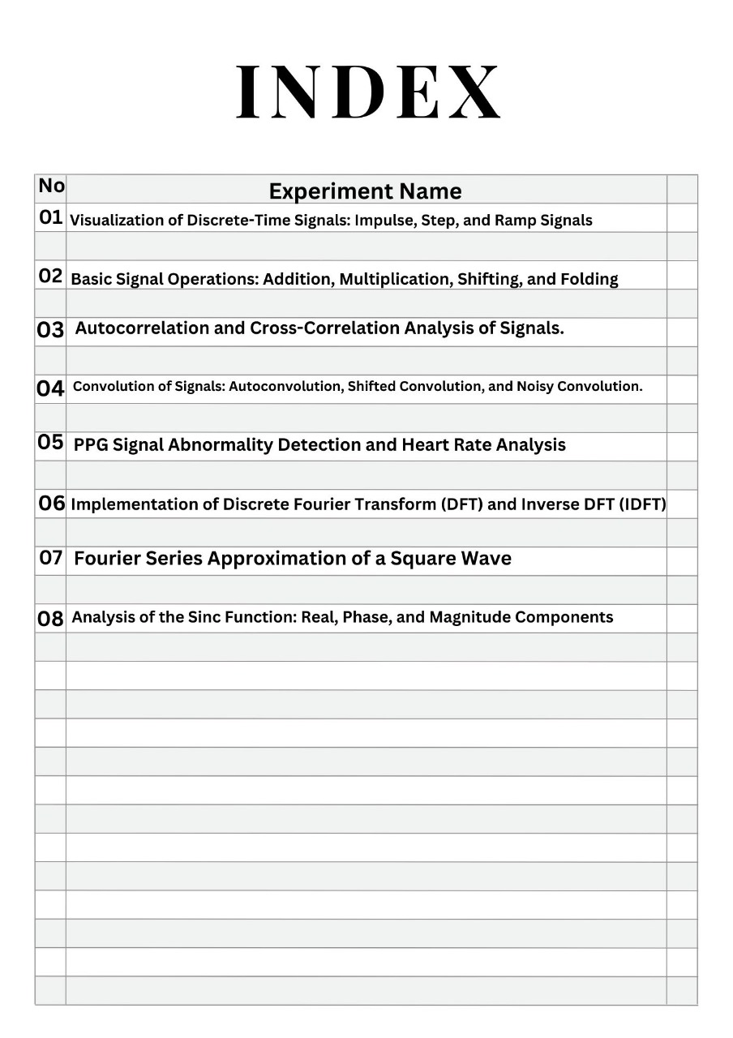

**Signals And Systems Lab Report**

**Experiment No-1:**

**Tittle:Visualization of Discrete-Time Signals: (Impulse,Step,and Ramp Signals )**

**Theory:**

• **Impulse Signal (δ[n])**: A discrete-time signal that is 1 at n = 0 and 0 elsewhere.

δ[n]={1if n=00if n≠0\delta[n] = \begin{cases} 1 & \text{if } n = 0 \\ 0 & \text{if } n \neq 0 \end{cases}δ[n]={10​if n=0if n=0​

• **Step Signal (u[n])**: A signal that is 0 for n < 0 and 1 for n ≥ 0.

u[n]={0if n<01if n≥0u[n] = \begin{cases} 0 & \text{if } n < 0 \\ 1 & \text{if } n \geq 0 \end{cases}u[n]={01​if n<0if n≥0​

• **Ramp Signal (r[n])**: A signal that increases linearly with n for n ≥ 0 and is 0 for n < 0.

r[n]={nif n≥00if n<0r[n] = \begin{cases} n & \text{if } n \geq 0 \\ 0 & \text{if } n < 0 \end{cases}r[n]={n0​if n≥0if n<0​

**Objectives:**

The goal of this experiment is to generate and analyze three fundamental discrete-time signals: Impulse, Step, and Ramp signals, and visualize their behavior.

**Code:**

import numpy as np

import matplotlib.pyplot as plt

# Define the range

n = np.arange(-10, 11)

def impulse_signal(n):

return np.where(n == 0, 1, 0)

def step_signal(n):

return np.where(n >= 0, 1, 0)

def ramp_signal(n):

return np.where(n >= 0, n, 0)

# Generate signals

impulse = impulse_signal(n)

step = step_signal(n)

ramp = ramp_signal(n)

# Plot signals

plt.figure(figsize=(12, 4))

plt.subplot(1, 3, 1)

plt.stem(n, impulse)

plt.title("Impulse Signal")

plt.xlabel("n")

plt.ylabel("Amplitude")

plt.grid()

plt.subplot(1, 3, 2)

plt.stem(n, step)

plt.title("Step Signal")

plt.xlabel("n")

plt.ylabel("Amplitude")

plt.grid()

plt.subplot(1, 3, 3)

plt.stem(n, ramp)

plt.title("Ramp Signal")

plt.xlabel("n")

plt.ylabel("Amplitude")

plt.grid()

plt.tight_layout()

plt.show()

Input:

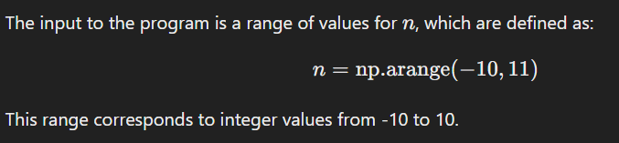

Output :

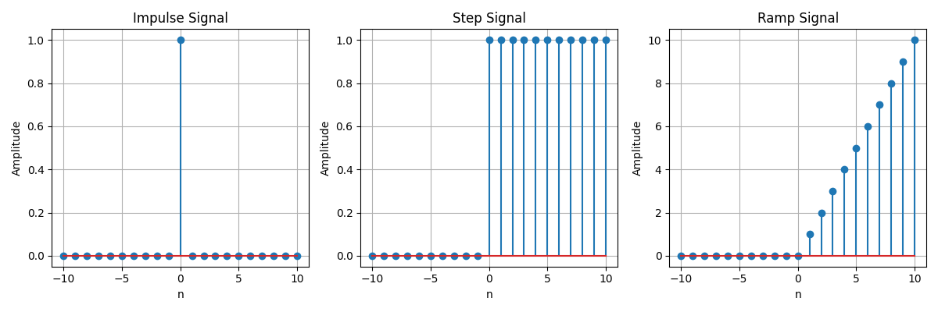

Purpose:

The purpose of this lab is to:

* Understand the properties and definitions of impulse, step, and ramp signals.
* Use Python to generate these signals over a range of nnn values.
* Visualize the signals using plots to analyze their behaviors.

**Experiment No-02:**

**Tittle: Signal Operations: Addition, Multiplication, Scaling, Shifting, and Folding**

Theory:

Signal processing involves manipulating signals to modify or enhance them. Common operations include:

* **Addition:** Combining two signals element-wise.
* **Multiplication:** Element-wise product of two signals.
* **Scaling:** Multiplying a signal by a constant to change its amplitude.
* **Shifting:** Translating a signal along the time axis.
* **Folding:** Reversing the signal with respect to time.

These operations are essential in fields like communications, audio processing, and control systems.

Objectives:

• **Learn basic signal operations** (addition, multiplication, scaling, shifting, folding).

• **Visualize the effects** of these operations on signals.

• **Understand real-world applications** of these operations in signal processing.

• **Practice using Python** for signal manipulation and visualization.

Code:

import numpy as np

import matplotlib.pyplot as plt

def signal_addition(x1, x2):

return x1 + x2

def signal_multiplication(x1, x2):

return x1 * x2

def signal_scaling(x, alpha):

return alpha * x

def signal_shifting(n, shift):

return n + shift

def signal_folding(x):

return np.flip(x)

n = np.array([-2, -1, 0, 1, 2])

x1 = np.array([1, 2, 3, 4, 5])

x2 = np.array([5, 4, 3, 2, 1])

added_signal = signal_addition(x1, x2)

multiplied_signal = signal_multiplication(x1, x2)

scaled_signal = signal_scaling(x1, 2)

shifted_signal1 = signal_shifting(n, -2)

shifted_signal2 = signal_shifting(n, 2)

folded_signal = signal_folding(x1)

plt.figure(figsize=(12, 10))

plt.subplot(4, 2, 1)

plt.stem(n, x1)

plt.xlabel("Time")

plt.ylabel("Amplitude")

plt.title("Original Signal x1")

plt.grid()

plt.subplot(4, 2, 2)

plt.stem(n, x2)

plt.xlabel("Time ")

plt.ylabel("Amplitude")

plt.title("Original Signal x2")

plt.grid()

plt.subplot(4, 2, 3)

plt.stem(n, added_signal)

plt.xlabel("Time")

plt.ylabel("Amplitude")

plt.title("Signal Addition")

plt.grid()

plt.subplot(4, 2, 4)

plt.stem(n, multiplied_signal)

plt.xlabel("Time")

plt.ylabel("Amplitude")

plt.title("Signal Multiplication")

plt.grid()

plt.subplot(4, 2, 5)

plt.stem(n, scaled_signal)

plt.xlabel("Time")

plt.ylabel("Amplitude")

plt.title("Scaled Signal (x1 * 2)")

plt.grid()

plt.subplot(4, 2, 6)

plt.stem(shifted_signal1, x1)

plt.xlabel("Time")

plt.ylabel("Amplitude")

plt.title("Shifted Signal (Shift = -2)")

plt.grid()

plt.subplot(4, 2, 7)

plt.stem(shifted_signal2, x1)

plt.xlabel("Time")

plt.ylabel("Amplitude")

plt.title("Shifted Signal (Shift = +2)")

plt.grid()

plt.subplot(4, 2, 8)

plt.stem(n, folded_signal)

plt.xlabel("Time")

plt.ylabel("Amplitude")

plt.title("Folded Signal (x1)")

plt.grid()

plt.tight_layout()

plt.show()

Input: 

Output :

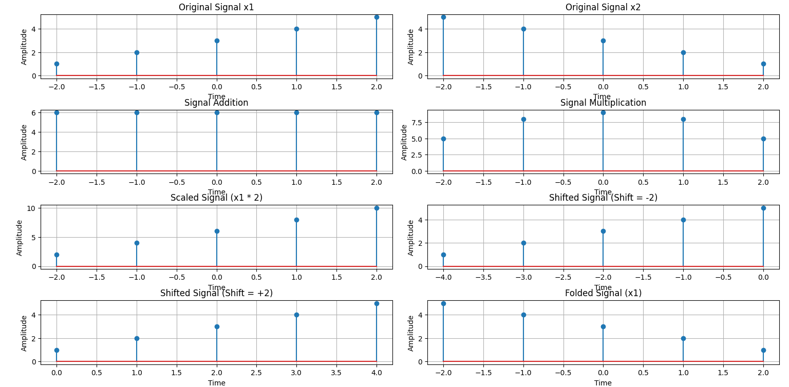

Purpose:

The purpose of the program is to demonstrate common signal operations, including signal addition, multiplication, scaling, shifting, and folding, and visualize their effects on the input signals.

**Experiment No-03:**

**Tittle: Autocorrelation and Cross-Correlation Analysis of Signals with Noise**

Theory:

* **Autocorrelation** measures the similarity of a signal with itself over different time lags, helping to identify periodicity or patterns within the signal.
* **Cross-correlation** measures the similarity between two signals, helping to detect relationships and align signals in time.

These techniques are used in signal detection, noise reduction, and time delay estimation.

Objectives:

1. Understand and compute **autocorrelation** and **cross-correlation**.
2. Analyze signal periodicity and the relationship between signals.
3. Visualize how correlation can help in real-world signal processing tasks.
4. Learn to implement these methods using Python libraries.

Code:

import numpy as np

import matplotlib.pyplot as plt

from scipy.signal import correlate, correlation_lags

def compute_autocorrelation(signal):

auto_corr = correlate(signal, signal, mode='full', method='auto')

lags = correlation_lags(len(signal), len(signal), mode='full')

return auto_corr, lags

def compute_cross_correlation(signal1, signal2):

cross_corr = correlate(signal1, signal2, mode='full', method='auto')

lags = correlation_lags(len(signal1), len(signal2), mode='full')

return cross_corr, lags

fs = 1000 # Sampling frequency in Hz

t = np.linspace(0, 1, fs, endpoint=False) # Time vector

freq = 5 # Frequency of the sine wave

sin_signal = np.sin(2 * np.pi * freq * t)

auto_corr, lags_auto = compute_autocorrelation(sin_signal)

signal1 = sin_signal

signal2 = np.roll(signal1, 100)

cross_corr, lags_cross = compute_cross_correlation(signal1, signal2)

noise = np.random.normal(0, 0.5, fs)

noisy_signal = signal1 + noise

cross_corr_noise, lags_noise = compute_cross_correlation(signal1, noisy_signal)

plt.figure(figsize=(12, 12))

plt.subplot(3, 1, 1)

plt.plot(lags_auto, auto_corr)

plt.title("Autocorrelation of a Sinusoidal Signal")

plt.xlabel("Lag")

plt.ylabel("Autocorrelation")

plt.grid()

plt.subplot(3, 1, 2)

plt.plot(lags_cross, cross_corr)

plt.title("Cross-Correlation between Two Signals")

plt.xlabel("Lag")

plt.ylabel("Cross-Correlation")

plt.grid()

plt.subplot(3, 1, 3)

plt.plot(lags_noise, cross_corr_noise)

plt.title("Cross-Correlation with Noisy Signal")

plt.xlabel("Lag")

plt.ylabel("Cross-Correlation")

plt.grid()

plt.tight_layout()

plt.show()

Input:

The input consists of:

* A sinusoidal signal with a frequency of 5 Hz, sampled at 1000 Hz.
* A shifted version of the sinusoidal signal for cross-correlation.
* A noisy version of the sinusoidal signal (created by adding random noise).

Output:

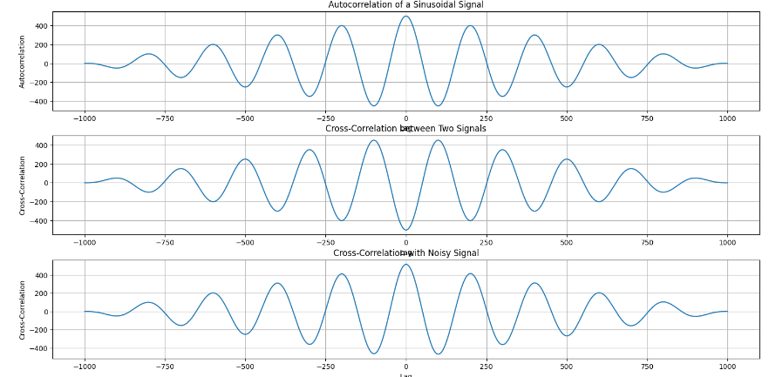

Purpose:

The purpose of this program is to compute and visualize:

1. The **autocorrelation** of a sinusoidal signal.
2. The **cross-correlation** between two signals (one being a shifted version of the other).
3. The **cross-correlation** between a sinusoidal signal and a noisy signal, to observe how noise affects the correlation.

**Experiment No: 04**

**Tittle: Convolution Analysis of Signals: Autoconvolution, Shifted Signals, and Noise Effects**

Theory:

Convolution is a mathematical operation that combines two signals to produce a third, showing their overlap as a function of time shift. Key concepts include:

* **Autoconvolution**: Convolving a signal with itself to detect patterns and periodicity.
* **Convolution with Shifted Signals**: Analyzing the similarity between a signal and its shifted version.
* **Convolution with Noisy Signals**: Studying the effect of noise on a signal through convolution.

Objectives:

• Understand and visualize **autoconvolution** and its properties.

• Analyze **convolution with shifted signals** to measure time shifts and similarity.

• Investigate the effect of **noise** in signal processing through convolution.

• Practice implementing convolution using **Python** and relevant libraries.

Code:

import numpy as np

import matplotlib.pyplot as plt

from scipy.signal import convolve

def compute_convolution(signal1, signal2):

conv_result = convolve(signal1, signal2, mode='full', method='auto')

return conv_result

fs = 1000 # Sampling frequency in Hz

t = np.linspace(0, 1, fs, endpoint=False) # Time vector

freq = 5 # Frequency of the sine wave

sin_signal = np.sin(2 * np.pi * freq * t)

conv_auto = compute_convolution(sin_signal, sin_signal)

signal1 = sin_signal

signal2 = np.roll(signal1, 100)

conv_shifted = compute_convolution(signal1, signal2)

noise = np.random.normal(0, 0.5, fs)

noisy_signal = signal1 + noise

conv_noisy = compute_convolution(signal1, noisy_signal)

plt.figure(figsize=(12, 12))

plt.subplot(3, 1, 1)

plt.plot(conv_auto)

plt.title("Autoconvolution of a Sinusoidal Signal")

plt.xlabel("Samples")

plt.ylabel("Convolution Output")

plt.grid()

plt.subplot(3, 1, 2)

plt.plot(conv_shifted)

plt.title("Convolution between Signal and Shifted Version")

plt.xlabel("Samples")

plt.ylabel("Convolution Output")

plt.grid()

plt.subplot(3, 1, 3)

plt.plot(conv_noisy)

plt.title("Convolution with Noisy Signal")

plt.xlabel("Samples")

plt.ylabel("Convolution Output")

plt.grid()

plt.tight_layout()

plt.show()

Input:

The input consists of:

* A sinusoidal signal with a frequency of 5 Hz, sampled at 1000 Hz.
* A shifted version of the sinusoidal signal for convolution.
* A noisy version of the sinusoidal signal (created by adding random noise)

Output :

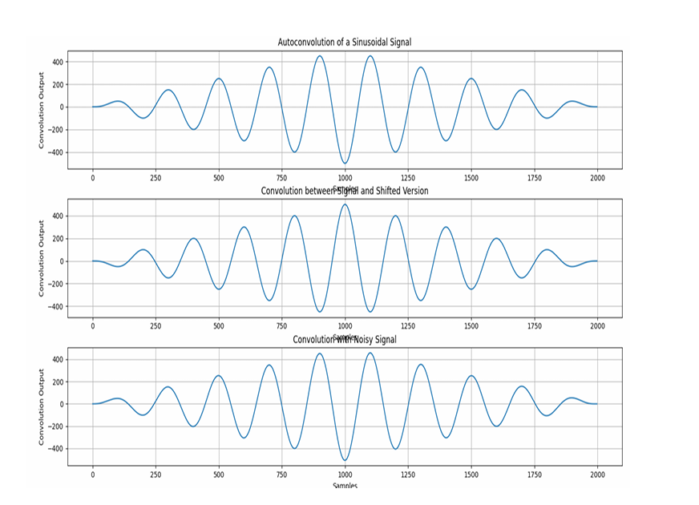

Purpose:

The purpose of this program is to compute and visualize:

1. The **autoconvolution** of a sinusoidal signal.
2. The **convolution** between a sinusoidal signal and its shifted version.
3. The **convolution** between a sinusoidal signal and a noisy signal, to observe the effect of noise on the convolution output.

**Experiment No- 05**

**Tittle - Heart Rate Estimation from PPG Signal Using Bandpass Filtering and Peak Detection**

Theory:

This code processes a PPG signal to estimate heart rate by:

1. **Bandpass Filtering**: Removes noise and retains frequencies relevant to the heart rate (0.5 Hz to 5 Hz).
2. **Peak Detection**: Identifies peaks in the signal corresponding to heartbeats.
3. **Heart Rate Estimation**: Calculates the heart rate by averaging the time intervals between peaks (R-R intervals).
4. **Normalization**: Scales the signal for easier peak detection.

**Objectives:**

• Apply **bandpass filtering** to clean the PPG signal.

• **Detect peaks** in the filtered signal.

• **Estimate heart rate** by analyzing the R-R intervals.

• Visualize the **signal processing stages**.

• Understand how signal processing techniques are used in **health monitoring** for heart rate estimation.

Code:

import numpy as np

import scipy.signal as signal

import matplotlib.pyplot as plt

def bandpass_filter(data, fs=100):

b, a = signal.butter(4, [0.5 / (0.5 * fs), 5.0 / (0.5 * fs)], btype='band')

return signal.filtfilt(b, a, data)

def detect_peaks(signal_data):

return signal.find_peaks(signal_data, distance=50)[0]

def extract_heart_rate(peaks, fs=100):

if len(peaks) < 2:

return 0

rr_intervals = np.diff(peaks) / fs

return 60 / np.mean(rr_intervals)

# Generate synthetic PPG signal

fs = 100

t = np.linspace(0, 10, fs * 10)

sine_signal = np.sin(2 * np.pi * 1.2 * t)

noise_signal = 0.1 * np.random.normal(0, 1, len(t))

ppg_signal = sine_signal + noise_signal

# Process PPG signal

filtered_signal = bandpass_filter(ppg_signal, fs)

normalized_signal = (filtered_signal - np.min(filtered_signal)) / (np.max(filtered_signal) -

np.min(filtered_signal))

peaks = detect_peaks(normalized_signal)

heart_rate = extract_heart_rate(peaks, fs)

# Print results

print("Filtered Signal (first 10 values):", filtered_signal[:10])

print("Detected Peaks (first 10 indices):", peaks[:10])

print(f"Estimated Heart Rate: {heart_rate:.2f} BPM")

# Plot results

plt.figure(figsize=(12, 9))

plt.subplot(3, 2, 1)

plt.plot(t, sine_signal, label='Raw Sine Signal')

plt.xlabel("Time")

plt.ylabel("Amplitude")

plt.legend()

plt.subplot(3, 2, 2)

plt.plot(t, noise_signal, label='Raw Noise Signal')

plt.xlabel("Time")

plt.ylabel("Amplitude")

plt.legend()

plt.subplot(3, 2, 3)

plt.plot(t, ppg_signal, label='Raw PPG Signal')

plt.xlabel("Time")

plt.ylabel("Amplitude")

plt.legend()

plt.subplot(3, 2, 4)

plt.plot(t, filtered_signal, label='Filtered PPG Signal')

plt.xlabel("Time")

plt.ylabel("Amplitude")

plt.legend()

plt.subplot(3, 2, 5)

plt.plot(t, normalized_signal, label='Normalized PPG Signal')

plt.xlabel("Time")

plt.ylabel("Amplitude")

plt.legend()

plt.subplot(3, 2, 6)

plt.plot(t, normalized_signal,label=f'PPG with Detected Peaks')

plt.plot(t[peaks], normalized_signal[peaks],'ro', label='Detected Peaks')

plt.xlabel("Time")

plt.ylabel("Amplitude")

plt.legend()

plt.tight_layout()

plt.show()

Input:

The input consists of:

* A synthetic PPG signal, created by adding a sine wave of 1.2 Hz frequency and Gaussian noise.
* A sampling frequency fs=100fs = 100fs=100 Hz.

**Output:**

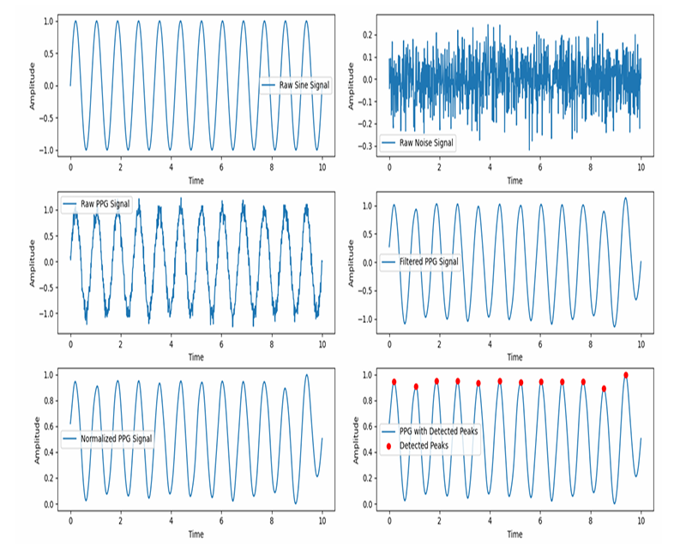

Purpose: The purpose of this program is to:

1. **Filter** the PPG signal using a bandpass filter.
2. **Normalize** the filtered signal for peak detection.
3. **Detect peaks** in the PPG signal.
4. **Estimate heart rate** based on the detected peaks by calculating the RR intervals and computing the average heart rate in beats per minute (BPM).

**Experiment No: 06**

**Tittle: Discrete Fourier Transform (DFT) and Inverse DFT (IDFT) of a Signal**

Theory:

* **DFT (Discrete Fourier Transform)** converts a time-domain signal into its frequency components, revealing the signal's frequency content.
* **IDFT (Inverse Discrete Fourier Transform)** reconstructs the original time-domain signal from its frequency components.

These transforms are essential in signal processing for tasks like spectrum analysis and signal reconstruction.

Objectives:

• Compute the **DFT** of a signal and analyze its frequency components.

• **Reconstruct** the signal using the **IDFT**.

• Visualize the original signal, its frequency spectrum, and the reconstructed signal.

Code:

mport numpy as np

import matplotlib.pyplot as plt

# Input sequence and N

x = [1,1,1,1]

N= 4

x = np.pad(x, (0, N - len(x)), mode='constant')

# DFT computation

X = np.fft.fft(x, N)

# IDFT computation (Inverse DFT)

x_reconstructed = np.fft.ifft(X)

# Print the DFT and IDFT values

print("DFT values:", X)

print("Reconstructed IDFT values:", x_reconstructed.real)

# Plot the input signal

plt.figure(figsize=(10, 6))

plt.subplot(3, 1, 1)

plt.stem(range(len(x)), x)

plt.title('Input Signal x(n)')

plt.xlabel('n')

plt.ylabel('x(n)')

plt.grid()

# Plot the magnitude of DFT

plt.subplot(3, 1, 2)

plt.stem(range(N), np.abs(X))

plt.title('DFT Magnitude |X(k)|')

plt.xlabel('k')

plt.ylabel('|X(k)|')

plt.grid()

# Plot the IDFT signal

plt.subplot(3, 1, 3)

plt.stem(range(N), x_reconstructed.real)

plt.title('Reconstructed Signal x(n) from IDFT')

plt.xlabel('n')

plt.ylabel('x(n)')

plt.grid()

plt.tight_layout()

plt.show()

Input:

The input consists of:

* A sequence x=[1,1,1,1]
* The length N=4 for the DFT computation.

**Output:**

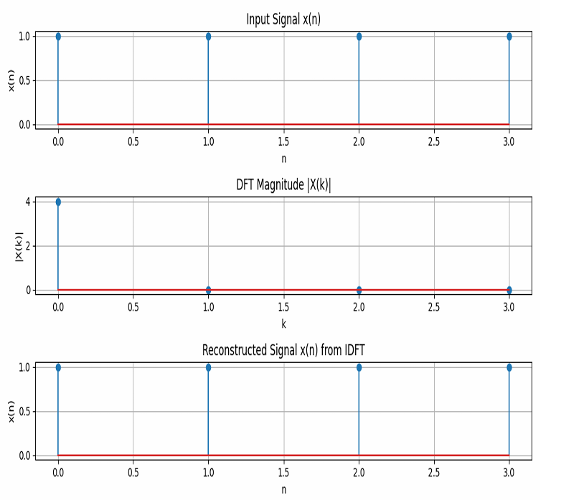

Purpose:

The purpose of this program is to:

1. **Compute the Discrete Fourier Transform (DFT)** of the input signal.
2. **Reconstruct the original signal** using the Inverse Discrete Fourier Transform (IDFT).
3. **Visualize** the input signal, the magnitude of the DFT, and the reconstructed signal.

**Experiment No: 07**

**Tittle : Fourier Series Approximation of a Square Wave**

Theory:

The **Fourier Series** is a mathematical tool used to express a periodic function as a sum of sine and cosine functions. It helps to approximate complex periodic signals using simpler sinusoidal components.

1. **Square Wave:**
   * A square wave is a periodic waveform that alternates between two levels, typically +1 and -1. It is a non-sinusoidal waveform, often used in digital signals and communications.
2. **Fourier Series Approximation:**
   * The Fourier series allows us to approximate any periodic function (such as a square wave) as a sum of sinusoidal functions (sines and cosines). For a square wave, the Fourier series consists only of odd harmonics (sine terms with odd multiples of the fundamental frequency).
   * As the number of terms in the Fourier series increases, the approximation becomes closer to the original square wave, exhibiting sharp transitions between the levels.

Objectives:

• **Understand Fourier Series:**

* Learn how Fourier series decompose a periodic function into a sum of sinusoidal components.

• **Approximate Square Wave:**

* Use Fourier series to approximate a square wave using a specified number of terms (odd harmonics).

• **Visualize Approximation:**

* Plot the original square wave and its Fourier series approximations with different numbers of terms to observe how the approximation improves as more terms are added.

• **Explore the Convergence of Fourier Series:**

* Study how increasing the number of terms in the Fourier series leads to a better approximation of the square wave, especially in terms of the sharp transitions.

Code:

import numpy as np

import matplotlib.pyplot as plt

def fourier_series(x, terms):

if terms < 1:

raise ValueError("Number of terms must be at least 1")

result = x - x

for n in range(1, terms + 1, 2):

result += (4 / (np.pi * n)) * np.sin(n * x)

return result

# Define the original square wave function

def square_wave(x):

return np.where(np.sin(x) >= 0, 1, -1)

# Generate x values

t = np.linspace(-np.pi, np.pi, 400)

# Plot different approximations

plt.figure(figsize=(8, 6))

# Plot the original square wave

plt.plot(t, square_wave(t), label='Original Square Wave', linestyle='--', color='black')

for terms in [1, 3, 5, 9]:

plt.plot(t, fourier_series(t, terms), label=f'{terms} terms')

plt.axhline(0, color='black', linewidth=0.5, linestyle='--')

plt.title('Fourier Series Approximation of a Square Wave')

plt.xlabel('Time')

plt.ylabel('Amplitude')

plt.legend()

plt.grid()

plt.show()

**Input:**

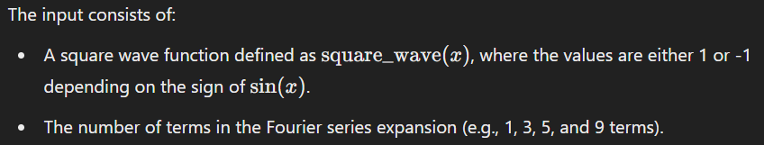

Output:

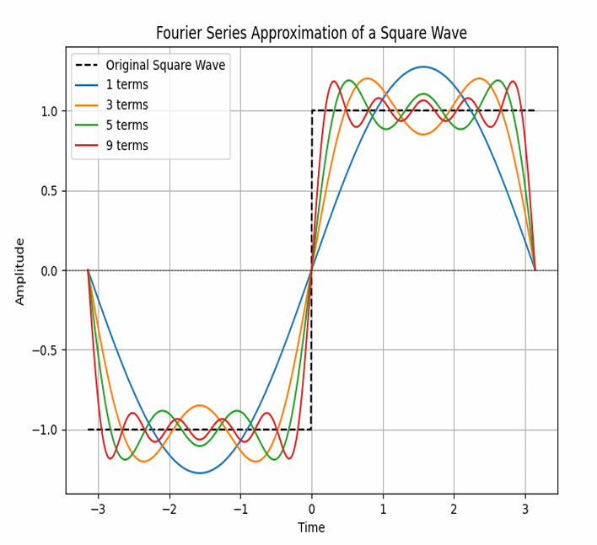

Purpose:

The purpose of this program is to:

1. **Approximate** a square wave using a Fourier series with different numbers of terms.
2. **Visualize** the approximation of the square wave for different numbers of terms in the Fourier series and compare it to the original square wave.

**Experiment No: 08**

**Tittle: visualizing the real, phase, and magnitude components of the sinc function.**

Theory:

e **sinc function** is defined as:

sinc(x)=sin⁡(πx)πx\text{sinc}(x) = \frac{\sin(\pi x)}{\pi x}sinc(x)=πxsin(πx)​

However, in this case, the function is scaled as sinc(4t)\text{sinc}(4t)sinc(4t), which is a normalized version of the sinc function.

1. **Real Part**: The real part of a complex signal is the actual value of the signal at any given time.
2. **Phase Part**: The phase represents the shift of the signal in time. It can be obtained using the **angle** of the signal, angle(x)\text{angle}(x)angle(x), which gives the phase of the complex values.
3. **Magnitude Part**: The magnitude represents the absolute value of the signal at any point in time. It provides information about the amplitude of the signal.

Objectives:

• **Plot the Real Part** of the sinc function to show its time-domain behavior.

• **Plot the Phase Part** to visualize how the phase varies across time (though, for real signals, this may remain constant or be zero).

• **Plot the Magnitude Part** to observe the amplitude of the sinc function and its decay with time.

• Understand the **sinc function's properties** and how it relates to signal processing and frequency response.

Code:

import numpy as np

import matplotlib.pyplot as plt

t = np.arange(-2, 2.01, 0.01)

x = 4 * np.sinc(4 * t)

# Plot real part

plt.figure(figsize=(10, 6))

plt.subplot(3, 1, 1)

plt.plot(t, x)

plt.xlabel('Time')

plt.ylabel('Amplitude')

plt.title('Real Part')

plt.grid()

# Plot phase part

plt.subplot(3, 1, 2)

plt.plot(t, np.angle(x))

plt.xlabel('Time')

plt.ylabel('Amplitude')

plt.title('Phase Part')

plt.grid()

# Plot magnitude part

plt.subplot(3, 1, 3)

plt.plot(t, np.abs(x))

plt.ylabel('Amplitude')

plt.title('Magnitude Part')

plt.grid()

plt.tight_layout()

plt.show()

Input:

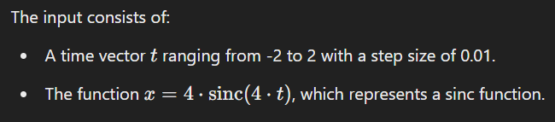

Output:

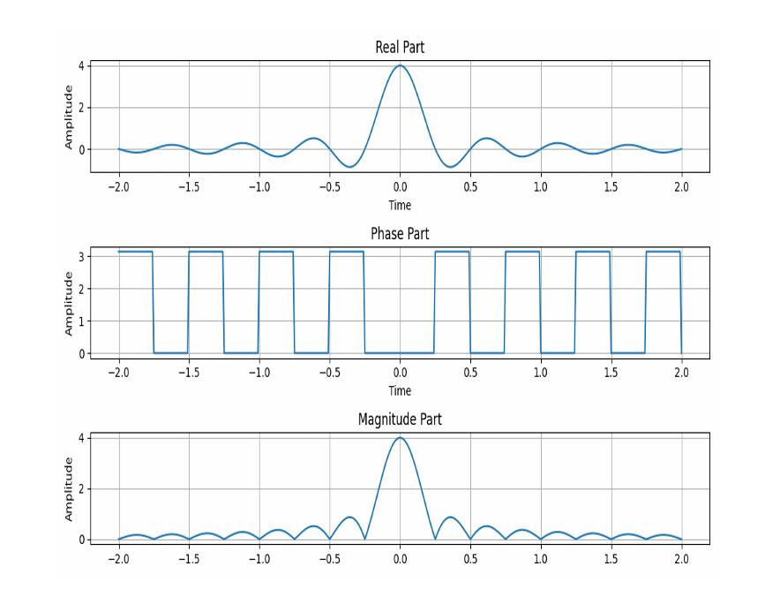

Purpose:

The purpose of this program is to:

1. **Visualize** the real part, phase part, and magnitude part of the sinc function xxx.
2. **Plot** these components to understand their characteristics over the given time range.